Town of West New York
Hudson County, New Jersey

Minutes of Regular Meeting
(Regular Session)
September 20, 2023

Commissioner Marcos A. Arroyo

Commissioner Victor M. Barrera
Commissioner Marielka A. Diaz
Commissioner Adam W. Parkinson
Mayor Albio Sires
Board of Commissioners

ATTEST: Adelinny plaza, rmc
town clerk

September 20, 2023
Regular Meeting

Minutes of a regular stated meeting of the Board of Commissioners of the Town of West New York, in the County of Hudson, State of New Jersey, held via Teleconference, on Wednesday, September 20, 2023 at 6:30 P.M. (No Work Session):

Present: Commissioners Arroyo, Barrera, Diaz, Parkinson, and Mayor Sires

Absent: None
Also Present: Town Clerk Adelinny Plaza, Town Administrator Luis Baez, Deputy Town Administrator Jonathan Castaneda, and Angelo Auteri, Esq. (Scarinci Hollenbeck)

Meeting commenced at 6:30 P.M.

Town Clerk Adelinny Plaza made the following announcement:

As presiding officer of this Regular Meeting of the Board of Commissioners of the Town of West New York, held on September 20, 2023 at 6:30 P.M (No Work Session), I do hereby publicly announce, and I direct that this announcement shall be placed in the minutes of this meeting, and that the Notice requirements provided for in the “Open Public Meetings Act” have been satisfied. Notice of this meeting was properly given by the Board of Commissioners in the Resolution dated and adopted on June 28, 2022. Said Resolution was transmitted by the Town Clerk to the Jersey Journal and the Bergen Record and publicly posted on the Municipal Bulletin Board, Town Hall, and filed with the Town Clerk. Notice of this meeting by the September 12, 2023 Sunshine Notice was transmitted to the aforementioned newspapers, posted on the municipal bulletin board in Town Hall, and on the Town Website.

Copies are available to the public in accordance with the law.

Note: Minutes were taken and transcribed by Town Clerk Adelinny Plaza and Tyara Conil.

Proclamation: (Swearing in Ceremony for Police Officers)

Note: Mayor Sires administered the oath of office to Police Officers Ariel L. Sanchez, Veronica B. Rivera, Oscar A. Negron, Soribel Ovalles Diaz, Robert Bailey, Ruben Rivera Jr., Armando Schipkowski, Johnathon D. Rosario, Jaiden Martinez, David. J. Nunez, Anthony M. Urdaneta and Belal S. Moustafa and Commissioner Adam W. Parkinson administered the oath of office to Special III Police Officers Jose Luis Alicea and Juan Carlos Nunez.

Payment of Claims: (Claims are available for public inspection in the Town Clerk’s Office)

It was regularly moved by Mayor Sires, seconded by Commissioner Barrera that the Payment of Claims of: September 20, 2023 be approved. The motion was carried by the following vote:

AYES - Commissioners Arroyo, Barrera, Diaz, Parkinson, and Mayor Sires
NAYS - None
ABSENT - None

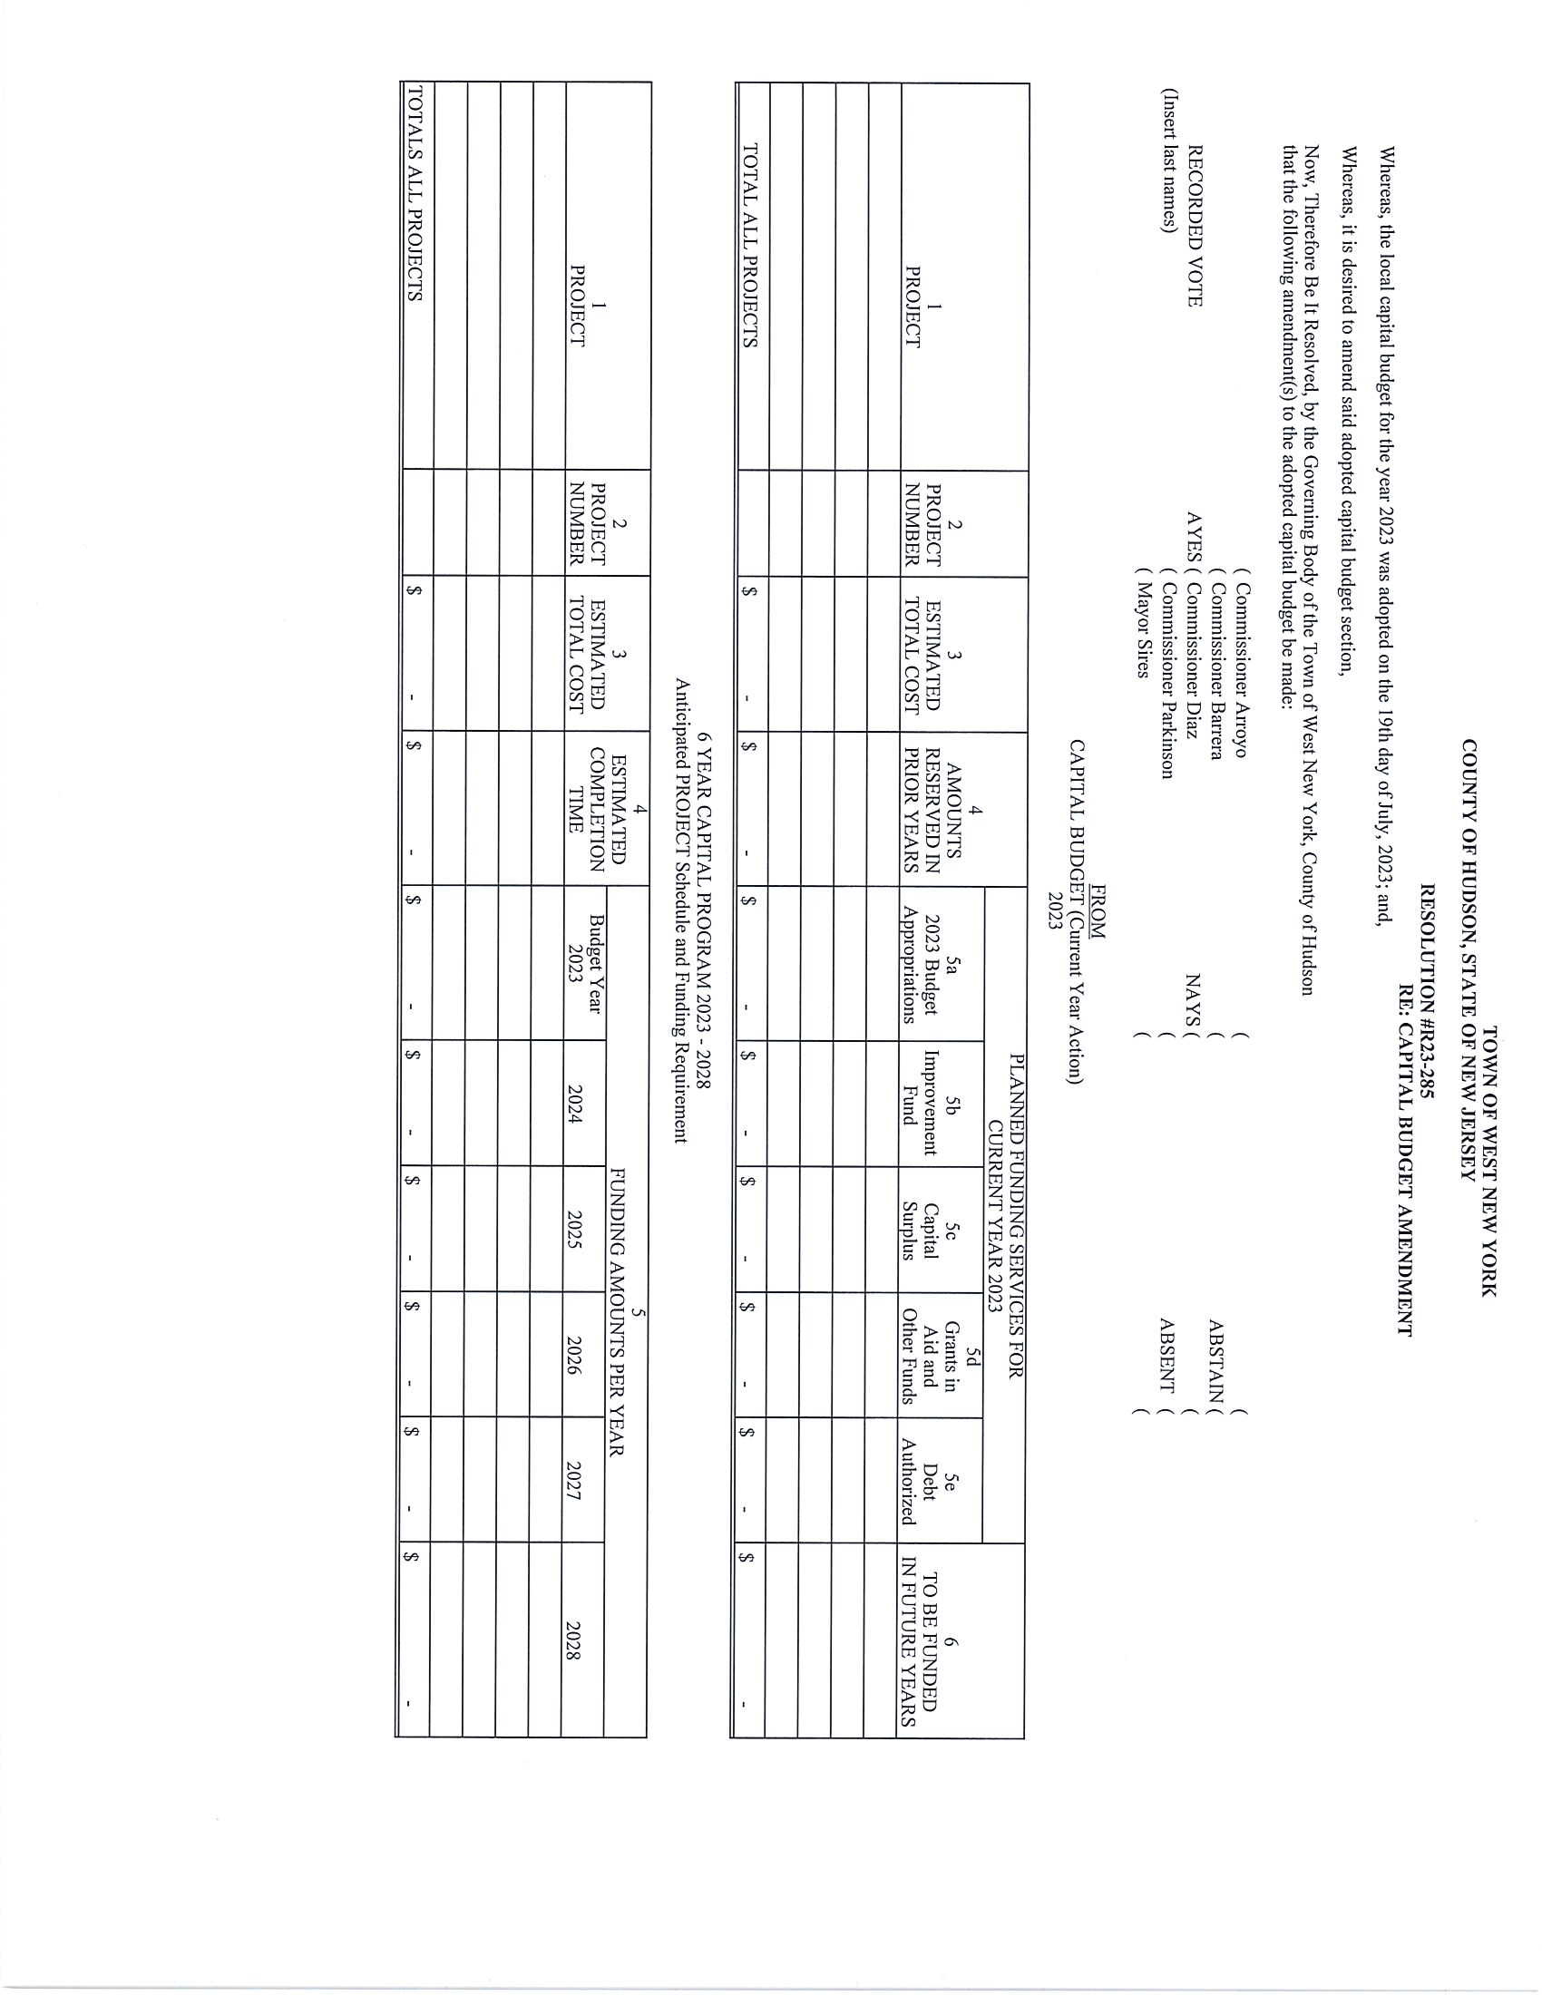
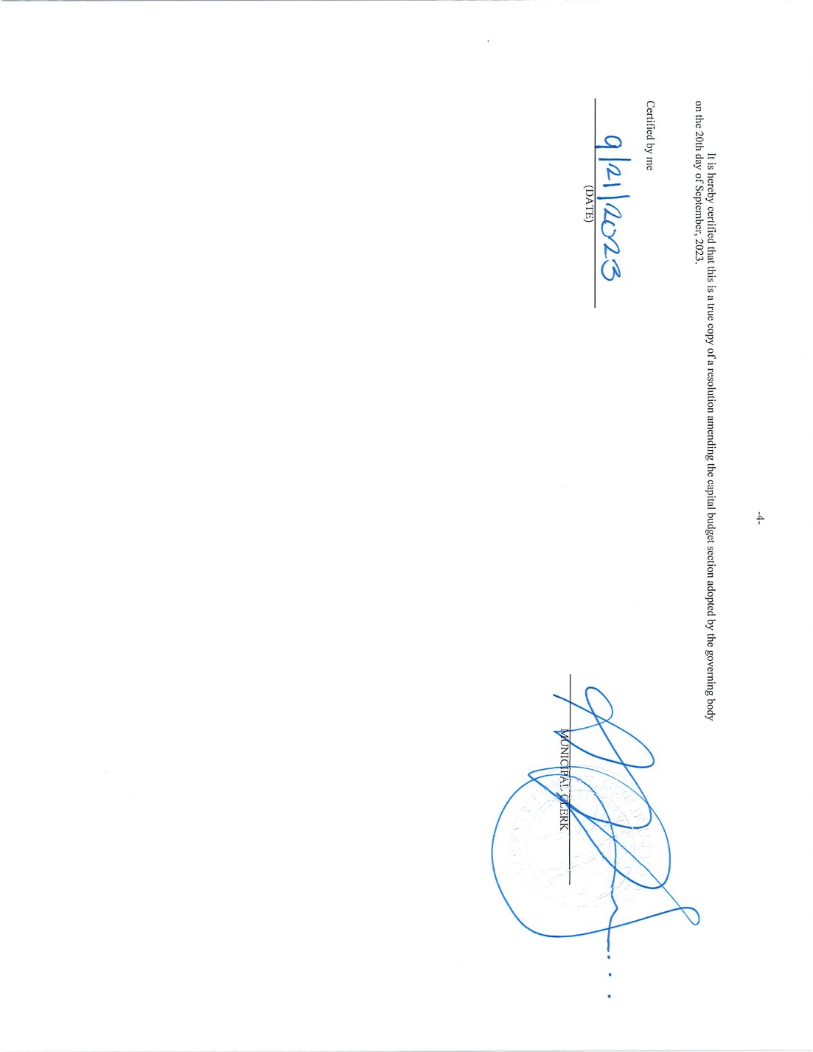
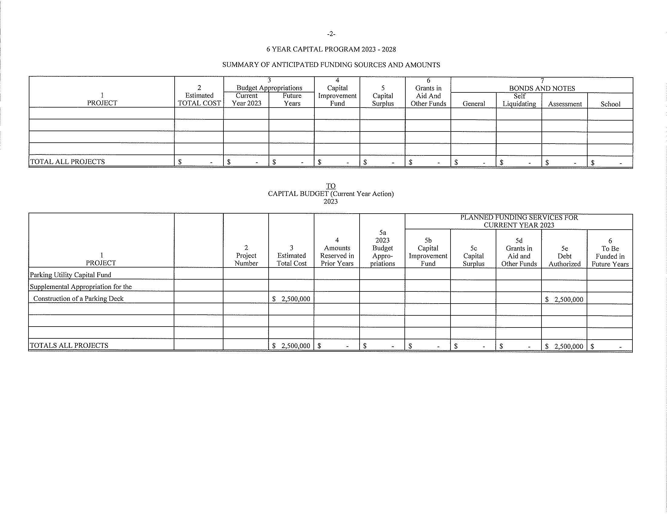
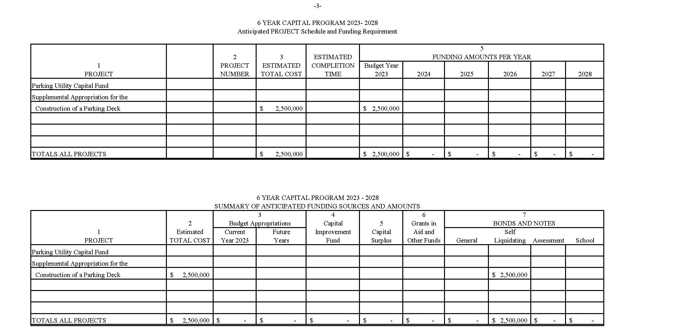
Motion was made by Commissioner Parkinson, seconded by Commissioner Arroyo, to adopt the foregoing Resolution, was carried by the following vote:

AYES - Commissioners Arroyo, Barrera, Diaz, and Parkinson
NAYS - None
ABSENT - Mayor Sires

September 20, 2023
Regular Meeting

Consent Agenda:

It was regularly moved by Mayor Sires, seconded by Commissioner Parkinson that the following Consent Agenda Items Nos. R23-286 through R23-306 (excluding #R23-285 Re: Capital Budget Amendment) to be adopted. The motion was carried by the following vote:

AYES - Commissioners Arroyo, Barrera, Diaz, Parkinson, and Mayor Sires
NAYS - None
ABSENT - None

Note: Town Clerk Adelinny Plaza announced that the consent agenda would include items #R23-286 through #R23-306, excluding #R23-285, which required a separate vote.

RESOLUTION #R23-286
RE: APPROVING THE 2023 AMENDED AND RESTATED CONSOLIDATED MUNICIPAL SERVICES AGREEMENT FOR A JOINT MEETING PURSUANT TO N.J.S.A. 40:48B-1 ET SEQ. (SEE NOW N.J.S.A. 40A:65-14 ET SEQ.), KNOWN AS NORTH HUDSON REGIONAL FIRE AND RESCUE.

WHEREAS, by previously adopted resolutions, North Bergen, West New York, Weehawken, Union City and Guttenberg (the “Municipalities”), authorized and approved (1) the Second Amended and Restated Consolidated Municipal Services Agreement For the Formation Of a Joint Meeting Pursuant To N.J.S.A. 40:48B-1 et seq. (see now N.J.S.A. 40A:65-14 et seq.), Known as North Hudson Regional Fire and Rescue (“Agreement”), and (2) three amendments to the Agreement, which together provided for the establishment and maintenance of a joint fire, rescue and coordinated communications joint meeting within the Municipalities; and,

WHEREAS, there is a need to extend the term of the Agreement, and consolidate the various amendments into a new consolidated agreement; and,

WHEREAS, a proposed 2023 Amended and Restated Consolidated Municipal Services Agreement For a Joint Meeting Pursuant To N.J.S.A. 40:48B-1 et seq. (see now 40A:65-14, et seq.), Known as North Hudson Regional Fire And Rescue (“2023 Agreement”), is attached to this Resolution and made a part hereof by reference; and,

WHEREAS, pursuant to N.J.S.A. 40:48B-4 (see now N.J.S.A. 40A:65-16), the 2023 Agreement is subject to approval by resolution of the Municipalities.

NOW, THEREFORE, BE IT RESOLVED by the Mayor and Board of Commissioners of the Town of West New York, in the County of Hudson, as follows:

- The aforesaid recitals are incorporated herein as though fully set forth at length.

- The 2023 Agreement be and it is hereby authorized and approved.

- The Mayor, Town Clerk, Municipal Administrator and/or Deputy Municipal Administrator and any other necessary Town official or employee, be and they are hereby authorized and directed to execute any and all documents and to take any and all actions necessary to complete and realize the intent and purpose of this Resolution, including the execution of the attached 2023 Agreement.

- The Town Clerk shall file a copy of this Resolution with the Director of the Division of Local Government Services in the Department of Community Affairs.

September 20, 2023
Regular Meeting

Consent Agenda (Cont.):
Resolution (Cont.):

- Any prior resolution or parts of resolutions inconsistent with the provisions of this Resolution are hereby repealed.

- If any part of this Resolution shall be declared unconstitutional, invalid, or inoperative, in whole or in part, by a court of competent jurisdiction, no such determination shall be deemed to invalidate the remainder of the Resolution.

RESOLUTION #R23-287
RE: CONCERNING PAYMENT OF CLAIMS FOR WORKERS COMPENSATION AND GENERAL LIABILITY FOR THE MONTH OF SEPTEMBER 2023

WHEREAS the Town of West New York has claims for bills to be paid under workers compensation and general liability; and

WHEREAS the Town of West New York is self-insured and participates with other communities in the Public Entity Joint Insurance Fund; and

WHEREAS the PE JIF, and Claims Administrator and the Town Administrator have reviewed all claims and recommend payment, and

WHEREAS the Chief Financial Officer has certified that funds are available for payment of these claims in account 21-75012 for Workers Compensation claims and account 21-75022 for General Liability claims, and

WHEREAS, the Board of Commissioners must approve payment of these claims; and

NOW THEREFORE, BE IT RESOLVED that the Mayor and Commissioners of the Town of West New York do hereby approve of the payment of the following claims:

Workers Compensation: $ 47,167.73
General Liability: $ 757,648.65

RESOLUTION #R23-288
RE: AUTHORIZING REFUND OF TAX LIEN REDEMPTIONS AND TAX LIEN PREMIUMS

WHEREAS, the investors named below have previously purchased Tax Sale Certificates from the Town of West New York; and

WHEREAS, the Tax Collector for the said Tax Sale Certificates has received the full amount for redemption pursuant to N.J.S.A. 54:5-60; and

WHEREAS, the Certificates have now been redeemed and the investor is entitled to a refund of said redemption amounts and premium amounts pursuant to N.J.S.A. 54:5-33 and N.J.S.A 54:5-33; and

NOW THEREFORE, BE IT RESOLVED, by the Mayor and Board of Commissioners of the Town of West New York, County of Hudson, State of New Jersey, that the below listed redemption and premium amounts be paid to the investors in the following amounts, and the Department of Revenue and Finance is hereby authorized to issue said refunds:

September 20, 2023
Regular Meeting

Consent Agenda (Cont.):
Resolution (Cont.):

LIEN HOLDER |  |  |  | TAX | REDEMPTION | PREMIUM
SEPTEMBER MEETING | BLK | LOT | QUAL | CERTIFICATE
EONE GROUP LLC | 47 | 16 |  | 19-0138 | $125,371.66 | $40,300.00
LB-HONEY BADGER SBMUNI CUST | 96 | 11 | C0047 | 21-0229 | $1,214.88 | $1,600.00
TRYSTONE CAPITAL ASSETS, LLC | 96 | 11 | C0047 | 22-0174 | $861.06 | $1,600.00
TRYSTONE CAPITAL ASSETS, LLC | 168.01 | 1 | C0339 | 22-0292 | $260.73 | $1,800.00
SUBTOTAL: |  |  |  |  | $ 128,471.01 | $ 45,300.00
TOTAL: |  |  |  |  | $ 173,771.01

RESOLUTION #R23-289
RE: AUTHORIZING REFUND OF TAX OVERPAYMENTS

WHEREAS, taxes with respect to the following properties have been inadvertently overpaid to the Town of West New York (“Town”) in the amounts hereafter stated; and

WHEREAS, it is necessary to make appropriate refunds for such overpayments.

NOW, THEREFORE BE IT RESOLVED, by the Mayor and Board of Commissioners of the Town of West New York, County of Hudson, and State of New Jersey that the following refunds be issued by the Department of Revenue and Finance with respect to the designated property and the Collector of Taxes be and is hereby authorized to adjust the records accordingly and to include the reimbursement of any applicable interest as a result of these overpayments:

NAME BLOCK/LOT AMOUNT YEAR

DON D MANIGAULT 5/32 C0601 $2,448.36 2023
6515 BLVD EAST UNIT 6A
WEST NEW YORK, NJ 07093

JANIECE LEE CROSBY 140/19 $595.00 2021
520 61ST STREET
WEST NEW YORK, NJ 07093

GLIA GROUP 116/10 $4,528.49 2023
1662 EAST 24TH STREET
BROOKLYN, NY 11229

GRAND TOTAL: $7,571.85

RESOLUTION #R23-290
RE: CREDITING OVERPAYMENT OF TAXES FROM 2022 TO 2023

WHEREAS, there is an overpayment in the amount of $2,081.68on the 4th quarter of 2022 tax bill for property located at 6507 Hudson Avenue a/k/a block 17 lot 12 and

WHEREAS, the taxpayer is requesting that their overpayment be moved to credit their 2023 tax bill on the said property.

September 20, 2023
Regular Meeting

Consent Agenda (Cont.):
Resolution (Cont.):

NOW THEREFORE BE IT RESOLVED, that the Tax Collector is hereby authorized to move the overpayment and to adjust the tax record accordingly.

NAME BLOCK/LOT AMOUNT YEAR OF THE YEAR
OVERPAYMENT TO CREDIT

PAREKH, I & S 17/12 $2,081.68 2022 2023

GRAND TOTAL $2,081.68

RESOLUTION #R23-291
RE: AMENDING RESOLUTION #R23-092 APPROVING CONTRACT FOR
THIRD PARTY ELEVATOR INSPECTION SERVICES WITH
NEW JERSEY ELEVATOR INSPECTION AGENCY

WHEREAS, the Town of West New York (“Town”) seeks to amend #R23-092 to set forth the term of the contract and payment details for agreement with New Jersey Elevator Inspection Agency for the performance of elevator inspection services.

NOW THEREFORE, BE IT RESOLVED that the Mayor and Board of Commissioners of the Town of West New York do hereby authorize the following amendments to #R23-092 awarding a contract with New Jersey Elevator Inspection Agency, located at 30 Amherst Place in Livingston, New Jersey, for the performance of elevator inspection services:

- The term of the contract is three (3) years, commencing July 10, 2023, with an option to renew, in accordance with, and subject to, applicable law, for up to two additional one year periods, for a total contract term not to exceed five (5) years.

- The Town shall pay New Jersey Elevator Inspection Agency 75% of the New Jersey Department of Community Affairs fees for its services in an amount not to exceed $160,000 over the course of the contract period, which will be paid from the fees collected by the Town from each property owner for who NJEIA performs inspection services. No minimum amount is guaranteed.

BE IT FURTHER RESOLVED, that all other terms shall remain in full force and effect.

BE IT FURTHER RESOLVED, the Mayor, Purchasing Agent and Town Clerk are authorized to take such other steps and to execute any documents necessary for this contract for the provision of emergency third party elevator inspection services.

BE IT FURTHER RESOLVED, that the Chief Financial Officer certifies that sufficient funds are available for this contract amendment in account number 13-286-56-000-002.

September 20, 2023
Regular Meeting

Consent Agenda (Cont.):

RESOLUTION #R23-292
RE: AMENDING RESOLUTION #R23-250 AUTHORIZING THE PURCHASE AND INSTALLATION OF ELECTRONIC NETWORK, SECURITY, AND CABLING EQUIPMENT FOR THE 57th STREET PARKING GARAGE

WHEREAS, by prior Resolution #R23-250, the Town West New York (“Town”) authorized the purchase of electronic network, security, and cabling equipment and installation for the 57th Street Parking Garage from JCT Solutions in the amount of $232,833.53 pursuant to the Union County Cooperative Purchasing System; and

WHEREAS, JCT Solutions has provided the Town with a revised quote (Quote #JCTC4217-06) for the purchase of the required electronic network, security, and cabling equipment and installation for the 57th Street Parking Garage pursuant to Union County Cooperative Purchasing Contract #8-UCCP 23-2021, valid through March 28, 2025, for an increased total amount of $249,525.43; and

WHEREAS, the Town seeks to amend Resolution #R23-250 to increase the total purchase amount for the purchase of the required electronic network, security, and cabling equipment and installation for the 57th Street Parking Garage Project pursuant to the revised quote (Quote #JCT4217-06) provided by JCT Solutions pursuant to Union County Cooperative Contract #8-UCCP 23-2021, for an amended total purchase amount not to exceed $249,525.43.

NOW THEREFORE, BE IT RESOLVED, that the Mayor and the Board of Commissioners of the Town of West New York, do hereby authorize the amendment of Resolution #R23-250 to increase the total purchase amount for the purchase of the required electronic network, security, and cabling equipment and installation for the 57th Street Parking Garage Project pursuant to the revised quote (Quote #JCT4217-06) provided by JCT Solutions pursuant to Union County Cooperative Contract #8-UCCP 23-2021, for an amended total purchase amount not to exceed $249,525.43.

BE IT FURTHER RESOLVED that the Temporary Purchasing Agent shall take all necessary steps to execute the documents to approve this purchase from JCT Solutions as set forth herein.

BE IT FURTHER RESOLVED that the Chief Financial Officer certifies that the necessary funds are available for this payment from account number 05-201-55-502-020-99.

RESOLUTION #R23-293
RE: AUTHORIZING ADDITIONAL INCREASE TO CONTRACT FOR LIFEGUARD SERVICES FOR THE TOWN OF WEST NEW YORK SWIM CLUB AND THE MILLER SPLASH PARK FOR 2023 SWIM-POOL SEASON

WHEREAS, by prior Resolution, the Town of West New York (the “Town”) awarded a contract to Pleasure Pool & Spa Management, located at 8306 5th Avenue, North Bergen, New Jersey 07047, for the provision of lifeguard services for the Town of West New York Swim Club and the Miller Park Splash Park for the 2022 swim-pool season; and

WHEREAS, by prior Resolution, the Town authorized the first one (1) year extension option to the contract with Pleasure Pool & Spa Management for the provision of lifeguard services for the 2023 swim-pool season for a total annual contract amount not to exceed $214,500.00; and

WHEREAS, by prior Resolution, the Town authorized an increase of $95,000.00 to the total amount for this contract to cover the increased hours and additional lifeguard services required by the Town through the end of the contract term for the 2023 swim-pool season, for an amended total contract amount not to exceed $309,500.00; and

September 20, 2023
Regular Meeting

Consent Agenda (Cont.):
Resolution (Cont.):

WHEREAS, the Town has determined that an additional increase in the amount of $45,000.00 is required to cover unforeseen circumstances and costs incurred by the Town for an increase in hours and additional lifeguard services required through the end of the contract period for the 2023 swim-pool season, for an amended total contract amount not to exceed $354,500.00.

WHEREAS, the Town seeks to authorize an increase in the amount of $45,000.00 to the total not to exceed amount for the Town’s contract with Pleasure Pool & Spa Management for the provision of lifeguard services for the 2023 swim-pool season for an amended total contract amount of $354,500.00 to cover the cost of additional lifeguard services required through the end of the contract term for the 2023 swim-pool season.

NOW THEREFORE, BE IT RESOLVED that the Mayor and the Board of Commissioners of the Town of West New York do hereby authorize an additional increase in the amount of $45,000.00 to the contract with Pleasure Pool & Spa Management for the provision of lifeguard services for the 2023 swim-pool season for an amended total contract amount of $354,500.00 to cover the cost of additional lifeguard services required through the end of the contract term for the 2023 swim-pool season.

BE IT FURTHER RESOLVED that the Mayor, the Town Administrator, and the Town Clerk are authorized to execute an amended contract for lifeguard services with Pleasure Pool & Spa Management as set forth herein.

BE IT FURTHER RESOLVED that the Chief Financial Officer certifies that the necessary funds for this contract are available from account 01-201-20-715-020-99.

RESOLUTION #R23-294
RE: AUTHORIZING SETTLEMENT IN WORKERS' COMPENSATION MATTER, HAMDI JABER V. WEST NEW YORK

WHEREAS, the Town of West New York (“Town”) is a party involved in pending Division of Workers' Compensation matter entitled, Hamdi Jaber v. Town of West New York (CRC-314-0003328); and
WHEREAS, Counsel for the Town of West New York has presented a proposed settlement in this matter; and
WHEREAS, Plaintiff and/or Plaintiff’s authorized representative has agreed to accept the aforementioned settlement.
NOW THEREFORE, BE IT RESOLVED that the Mayor and the Board of Commissioners of the Town of West New York, County of Hudson, State of New Jersey do hereby authorize the settlement of the workers compensation matter, entitled Hamdi Jaber v. Town of West New York (CRC-314-0003328) as recommended by Counsel for the Town of West New York.
BE IT FURTHER RESOLVED that the Mayor and the Board of Commissioners of the Town of West New York authorize the Town's third-party administrator to make the settlement payment as set forth pursuant to the terms of the settlement agreement within the time period prescribed by law.
BE IT FURTHER RESOLVED that Plaintiff has provided or shall provide to Counsel for the Town of West New York a satisfactory release, closing documents and/or other appropriate documentation.

September 20, 2023
Regular Meeting

Consent Agenda (Cont.):

RESOLUTION #R23-295
RE: ESTABLISHING RATES FOR ELECTRIC VEHICLE CHARGING STATIONS WITHIN THE TOWN OF WEST NEW YORK
WHEREAS, the Town of West New York (the “Town”) has installed or will install electric vehicle charging stations and infrastructure within the Town; and
WHEREAS, supporting the transition to electric vehicles contributes to the Town’s commitment to sustainability and is in the best interest of the public welfare; and
WHEREAS, installing electric vehicle charging stations supports the State of New Jersey’s goals to reduce air pollutants and greenhouse gas emissions from the transportation sector as outlined and supported by various programs related to NJ’s 2019 Energy Master Plan, Global Warming Response Act (P.L.2007, c.112 (C.26:2C-37 et al.)), and EV Law (P.L. 2019, c. 362); and
WHEREAS, the Town charges fees for various services provided by the Town to cover the costs of providing such services; and
WHEREAS, Town administration researched and compared existing energy rates at electric vehicle charging stations in the State of New Jersey; and
WHEREAS, the Town seeks to establish rates to charge the users of the electric vehicle charging stations.
NOW THEREFORE, BE IT RESOLVED that the Mayor and the Board of Commissioners for the Town of West New York, do hereby authorize a fee of $0.30 per kilowatt hour for electric vehicle charging stations.
BE IT FURTHER RESOLVED that the maximum time a vehicle may use and/or remain parked at a charging station shall be five (5) hours. An overstay fee of five ($5.00) dollars shall be charged for any vehicle using or parked at a charging station beyond five (5) hours.
BE IT FURTHER RESOLVED that the Mayor, Town Administrator, and Town Clerk are authorized to take such other steps as are necessary to effectuate the purposes of this Resolution.

RESOLUTION #R23-296
RE: APPROVING CHANGE ORDER #4, #5, #6 #7 AND #8 AND PAY CERTIFICATE #15 FOR MILLER PARK IMPROVEMENTS, PLAYGROUND & DOG PARK PROJECT WITH ADAMO BROTHERS CONSTRUCTION, INC.

WHEREAS, the Town of West New York (“the Town”) entered a contract with Adamo Brothers Construction, Inc., located at 1033 Alexander Avenue, Ridgefield, NJ 07657, to complete the Miller Park Improvements, Playground, and Dog Park Project in the Town of West New York for an original total contract amount, inclusive of all allowances, of $4,423,000.00; and

WHEREAS, by prior Resolution, the Town approved Change Orders #1, #2, and #3 authorizing a net increase of $122,182.39 to the total contract for the Miller Park Improvements, Playground & Dog Park Project, for an amended total contract amount not to exceed $4,545,182.39 (After Change Orders #1, #2, and #3); and

WHEREAS, Adamo Brothers Construction, Inc., has submitted Change Order #4 in the amount of $122,182.39 due to unforeseen costs associated with removal of existing tree stumps, adding additional trees, and the addition of an irrigation system for the Miller Park Improvements, Playground & Dog Park Project, to increase the total contract amount to $4,683,001.39 (After Change Order #4); and

September 20, 2023
Regular Meeting

Consent Agenda (Cont.):
Resolution (Cont.):

WHEREAS, Adamo Brothers Construction, Inc., has submitted Change Order #5 in the amount of $19,449.00 due to unforeseen costs associated with the installation of a new hose connection, fencing, and gates at the dog park for the Miller Park Improvements, Playground & Dog Park Project, to increase the total contract amount to $4,702,450.39 (After Change Order #5); and
WHEREAS, Adamo Brothers Construction, Inc., has submitted Change Order #6 in the amount of $11,781.00 due to additional costs associated with the installation of a new concrete sidewalk and curb at the Jackson Avenue Entrance for the Miller Park Improvements, Playground & Dog Park Project, to increase the total contract amount to $4,714,231.39 (After Change Order #6); and

WHEREAS, Adamo Brothers Construction, Inc., has submitted Change Order #7 in the amount of $38,091.83 due to unforeseen additional costs associated with the installation additional sport netting at the south end of the soccer field for the Miller Park Improvements, Playground & Dog Park Project, to increase the total contract amount to $4,752,323.22 (After Change Order #7); and
WHEREAS, Adamo Brothers Construction, Inc., has submitted Change Order #8 in the amount of $8,739.18 due to additional costs associated with the installation of a dedication plaque not originally included within the scope of the work and the base bid amount for the Miller Park Improvements, Playground & Dog Park Project, to increase the total contract amount to $4,761,062.40 (After Change Order #8); and

WHEREAS, Adamo Brothers Construction, Inc., has additionally submitted Payment Certificate #15 in the amount of $106,368.69 for work performed within the scope of the Miller Park Improvements, Playground & Dog Park Project (Project Nos. 06-19.001); and

WHEREAS, RSC Architects, the firm overseeing this Project on behalf of the Town of West New York, has reviewed Change Order #4 in the amount of $122,182.39, Change Order #5 in the amount of $19,449.00, Change Order #6 in the amount of $11,781.00, Change Order #7 in the amount of $38,091.83, Change Order #8 in the amount of $8,739.18 submitted by Adamo Brothers Construction, Inc. to collectively increase the total amount for the Miller Park Improvements, Playground & Dog Park Project to $4,761,062.40 (After Change Order #4, #5, #6, #7, and #8) and has recommend approval of same by the Town; and

WHEREAS, RSC Architects has reviewed Payment Certificate #15 in the amount of $106,368.69 submitted by Adamo Brothers Construction in connection with the Miller Park Improvements, Playground & Dog Park Project and has recommended approval and payment of same by the Town.

NOW THEREFORE, BE IT RESOLVED that the Mayor and the Board of Commissioners of the Town of West New York do hereby authorize as follows:

- The above recitals are incorporated herein.

- Change Order #4 in the amount of $122,182.39, Change Order #5 in the amount of $19,449.00, Change Order #6 in the amount of $11,781.00, Change Order #7 in the amount of $38,091.83, Change Order #8 in the amount of $8,739.18 submitted by Adamo Brothers Construction, Inc. to collectively increase the total amount for the Miller Park Improvements, Playground & Dog Park Project to $4,761,062.40 (After Change Order #4, #5, #6, #7, and #8).

September 20, 2023
Regular Meeting

Consent Agenda (Cont.):
Resolution (Cont.):

- Payment Certificate #15 to Adamo Brothers Construction, Inc. in the amount of $106,368.69 for the Miller Park Improvements, Playground & Dog Park Project is hereby approved.

BE IT FURTHER RESOLVED that the Mayor, Municipal Administrator, RSC Architects, and the Town Clerk are authorized to take any additional steps necessary to authorize the Change Orders as set forth herein and to further effectuate the purposes detailed in this Resolution.

BE IT FURTHER RESOLVED that the Chief Financial Officer certifies that sufficient funds are available for this contract in account number 04-215-55-923-001.

RESOLUTION #R23-297
RE: TO AUTHORIZE A TWO (2) YEAR EXTENSION TO THE CONTRACT WITH TROY AND BANKS FOR UTILITY AUDITING SERVICES PURSUANT TO TIPS COOPERATIVE PURCHASING PROGRAM
WHEREAS, by prior Resolution #R22-185, the Town West New York (“Town”) authorized a contract with Troy and Banks pursuant to The Interlocal Purchasing System (“TIPS”), in accordance with N.J.S.A. 52:34-6.2(b), for the provision of utility auditing and consulting services, for a total amount for the contract not to exceed $17,500.00, for a term which expired on May 31, 2023.; and
WHEREAS, pursuant to N.J.S.A. 52:34-6.2(b) the Town is authorized to, without engaging in a competitive bidding process, purchase of goods or services pursuant to an agreement awarded through to a nationally recognized and accepted cooperative purchasing program; and
WHEREAS, the Town of West New York is a member of the TIPS cooperative purchasing program; and
WHEREAS, the Town seeks to authorize a two (2) year extension to the contract with Troy and Banks through August 31, 2025, for the provision of utility auditing and consulting services to promote cost savings due to overcharges, billing errors, and discrepancies in accordance with TIPS Contract #230601; and
WHEREAS, pursuant to TIPS Contract #230601, Troy and Banks will continue to perform utility auditing and consulting services for the Town and the Town is only required to provide payment in the amount of 33% of the total refund or savings obtained for the Town through these services, it will cost the Town $0.00 if there is no refund or savings obtained through Troy’s services; and
WHEREAS, the Mayor and the Board of Commissioners of the Town of West New York seek to authorize a two (2) year extension to the contract with Troy and Banks for the provision of utility audit consulting services pursuant to TIPS Contract #230601 through August 31, 2025; and
WHEREAS, the total value of the services provided to the Town pursuant to a contract with Troy and Banks, LLC for the relevant period, will not exceed the bid threshold.
NOW THEREFORE, BE IT RESOLVED, that the Mayor and the Board of Commissioners of the Town of West New York hereby authorize a two (2) year extension to the contract with Troy and Banks for the provision of utility auditing and consulting services pursuant to TIPS Contract #230601, until August 31, 2025, for an amount not to exceed $17,000.00.
BE IT FURTHER RESOLVED, that pursuant to TIPS Contract #230601, the Town would only pay Troy and Banks if there is a finding of refund and or saving in the amount of 33% of what is saved (up to $17,000) and if nothing is found it will cost the Town $0.00.
September 20, 2023
Regular Meeting

Consent Agenda (Cont.):
Resolution (Cont.):

BE IT FURTHER RESOLVED that the Mayor, Town Administrator, and the Town Clerk are authorized to take any steps necessary to authorize an extension to the contract with Troy and Banks pursuant to TIPS Contract #230601 and to further effectuate the purposes as set forth herein.
BE IT FURTHER RESOLVED, that the governing body of the Town of West New York pursuant to N.J.A.C. 5:30-5.5(b), the certification of available funds, shall either certify the full maximum amount against the budget at the time the contract is awarded, or no contract amount shall be chargeable or certified until such time as the goods or services are ordered or otherwise called for prior to placing the order, and a certification of availability of funds is made by the Chief Municipal Finance Officer.
RESOLUTION #R23-298
RE: APPOINTING EDUARDO VALDIVIA AS INTERIM FIRE OFFICIAL
WHEREAS, the Town of West New York (the “Town”) is in need of an Interim Fire Official due to a leave of absence by the current Fire Official; and
WHEREAS, the Commissioner of the Department of Public Works seeks to appoint Eduardo Valdivia as Interim Fire Official effective September 13, 2023; and
WHEREAS, Eduardo Valdivia possesses the requisite certifications and licensure to serve as Interim Fire Official; and
WHEREAS, the provisions of N.J.S.A 52:27D-203(b) require the appointment of a Fire Official to be made by Resolution of the governing body.
NOW, THEREFORE, BE IT RESOLVED, that in accordance with the provisions of N.J.S.A. 52:27-203(b) and N.J.A.C. 5:71-2.1 et seq., Eduardo Valdivia is appointed as the Interim Fire Official for the Town, effective September 13, 2023 until further notice from the Commissioner of the Department of Public Works.
BE IT FURTHER RESOLVED, that the Town Clerk is authorized to forward a copy of this resolution to the State of New Jersey Department of Community Affairs.

RESOLUTION #R23-299

RE: AUTHORIZING CONTRACTS WITH CERTAIN APPROVED COOPERATIVE AGREEMENT VENDORS FOR CONTRACTING UNITS PURSUANT TO N.J.S.A. 40A:11-10

WHEREAS, the Town of West New York (“Town”), pursuant to N.J.S.A. 40A:11-10 and N.J.A.C. 5:34-7.11, may by resolution and without advertising for bids, purchase any goods or services through duly formed cooperative purchasing systems; and

WHEREAS, the procurement of goods and services through a cooperative purchasing program is considered to be an open and fair process under the New Jersey Pay-to-Play Law N.J.S.A. 19:44A-20.4 et. seq.; and

WHEREAS, the Town intends to enter into contracts with the attached Referenced Cooperative purchasing system vendors through this resolution and properly executed cooperative agreements, which shall be subject to all the conditions of applicable laws.

NOW, THEREFORE, BE IT RESOLVED, that the Mayor and Commissioners of the Town of West New York, County of Hudson, State of New Jersey do hereby authorize the Purchasing Agent to purchase certain goods or services from those approved Cooperative Pricing System Contract Vendors on the attached list.

September 20, 2023
Regular Meeting

Consent Agenda (Cont.):
Resolution (Cont.):

BE IT FURTHER RESOLVED, that the Mayor and Commissioners of the Town of West New York pursuant to N.J.A.C. 5:30-5.5(b), the certification of available funds, shall either certify the full maximum amount against the budget at the time the contract is awarded, or no contract amount shall be chargeable or certified until such time as the goods or services are ordered or otherwise called for prior to placing the order, and a certification of availability of funds is made by the Chief Finance Officer; and

BE IT FURTHER RESOLVED, that the duration of the contracts between the Town
of West New York and the Referenced Cooperative Pricing System Contract Vendors shall be based on the term of the appropriate Cooperative Pricing System contract.

New Jersey Cooperative Purchasing Vendors

Vendor Name | Description | Expire Date | NTE Amount
SANITATION EQUIPMENT CORP. | ESCNJ 20/21-55 TRUCKS - CLASS 4 - 8 - BID | 6/30/2025 | $ 50,000.00
Elizabeth Truck Center | SCC-0029-22Collision Repairs & Vehicle Painting | 9/27/2024 | $ 50,000.00
MINER, LTD. | 21-03 HCESC-Cat/Ser- Overhead Door Repair & Replacement | 3/22/2025 | $ 50,000.00
JUNTARTI NJOTOPRAWIRO | ESCNJ 21/22-07 Uniforms & Workwear | 9/3/2024 | $ 75,000.00
W.E. TIMMERMAN EQUIPMENT,INC. | ESCNJ 20/21-55 TRUCKS - CLASS 4 - 8 | 6/3/2025 | $ 50,000.00
CLIFFSIDE BODY CORP. | ESCNJ 23/24-04 Class 4 - 8 Trucks | 06/30/2025 | $ 50,000.00
NATIONAL HIGHWAY PRODUCTS, INC. | SCC-0099-22 Traffic Control Signs, Supports & Hardware Devices | 9/27/2024 | $ 30,000.00
AMERICAN PAPER TOWEL CO, LLC | HCESC-Cat-23-02 Custodial Supplies & Equipment | 02/24/2024 | $ 50,000.00
NORTHEASTERN INTERIOR SERVICES LLC | HCESC-Ser-20F General Construction Carpentry & Repair Services | 11/2/2024 | $ 50,000.00
KEVIN DOWNES TREE SERVICE CO, INC | HCESC-SER-20H Tree Trimming, Pruning & Removal Services | 11/3/2024 | $ 100,000.00

RESOLUTION #R23-300

RE: AUTHORIZING CONTRACTS WITH CERTAIN APPROVED STATE CONTRACT VENDORS FOR CONTRACTING UNITS
PURSUANT TO N.J.S.A. 40A:11-12a

WHEREAS, the Town of West New York (“Town”), pursuant to N.J.S.A. 40A:11-12a and N.J.A.C. 5:34-7.29(c), may by resolution and without advertising for bids, purchase any goods or services under the State of New Jersey Cooperative Purchasing Program for any State contracts entered into on behalf of the State by the Division of Purchase and Property in the Department of the Treasury; and

WHEREAS, the Town has the need on a timely basis to purchase goods or services utilizing State contracts; and

WHEREAS, the Town intends to enter into contracts with the attached Referenced State Contract Vendors through this resolution and properly executed contracts, which shall be subject to all the conditions applicable to the current State contracts.

September 20, 2023
Regular Meeting

Consent Agenda (Cont.):
Resolution (Cont.):

NOW, THEREFORE, BE IT RESOLVED, that the Mayor and the Board of Commissioners of the Town of West New York, County of Hudson, State of New Jersey authorizes the Temporary Qualified Purchasing Agent to purchase certain goods or services from those approved New Jersey State Contract Vendors on the attached list, pursuant to all conditions of the individual State contracts; and

BE IT FURTHER RESOLVED, that the governing body of the Town of West New York pursuant to N.J.A.C. 5:30-5.5(b), the certification of available funds, shall either certify the full maximum amount against the budget at the time the contract is awarded, or no contract amount shall be chargeable or certified until such time as the goods or services are ordered or otherwise called for prior to placing the order, and a certification of availability of funds is made by the Chief Municipal Finance Officer; and

BE IT FURTHER RESOLVED, that the duration of the contracts between the Town
of West New York and the Referenced State Contract Vendors shall be based on the term of the appropriate State contract.

New Jersey State Contract Cooperative Purchasing Vendors

Vendor Name | Description | Expire Date | NTE Amount
CONSOLIDATED STEEL & ALUMINUM FENCE CO. | 88680 T0640 - FENCE: CHAIN LINK, ROCK FALL, WOODEN, VINYL AND ORNAMENTAL (INSTALL & REPLACE) | 6/30/2024 | $ 100,000.00
DELL INC | 19-TELE-00656 M0483 - COMPUTER EQUIPMENT, PERIPHERALS & RELATED SERVICES | 10/31/2023 | $ 50,000.00
EAST COAST EMERGENCY LIGHTING, INC | 17-FLEET-00761 T0106 - Law Enforcement Firearms Equipment and Supplies | 5/13/2024 | $ 50,000.00
Emergency Accessories & Installations Inc. | 17-FLEET-00748 T0106 - Law Enforcement Equipment and Supplies | 5/13/2024 | $ 25,000.00
FACSIMILE COMMUNICATIONS INDUSTRIES INC. | 40467 G2075 - COPIERS & MULTI-FUNCTION DEVICES, MAINTENANCE, SUPPLIES & PRINT SERVICES | 8/11/2024 | $ 75,000.00
FM GENERATOR INC. | 20-GNSV2-01163 T2848 - Preventive Maintenance and Testing of Generators | 5/31/2024 | $ 50,000.00
FOERTSCH HOLDINGS INC. D/B/A TELREPCO | 89980 M0483 - COMPUTER EQUIPMENT, PERIPHERALS & RELATED SERVICES | 10/31/2023 | $ 50,000.00
FRED BEANS PARTS INC | 85995 Non OEM Automotive Parts & Accessories 19-FLEET-00919 | 8/4/2024 | $ 25,000.00
G.T.B.M. INC | 89980 M0483 - COMPUTER EQUIPMENT, PERIPHERALS & RELATED SERVICES | 10/31/2023 | $ 20,000.00
PATCH MANAGEMENT, INC. | 18-GNSV2-00428 T2817 - Rental of a Truck Mounted Spray Injection Patching System and Mastic Melter for NJDOT | 7/31/2024 | $ 50,000.00
T. SLACK ENVIRONMENTAL SERVICES INC | 42266 T0849 - ABOVEGROUND FUEL TANKS, ASSOC. EQUIP., INSTALLATION, TANK REMOVAL, & SYS. SVCS | 8/28/2024 | $ 30,000.00
THOMAS J MORRIS III | 17-FLEET-00721 T0106 - Law Enforcement Firearms Equipment and Supplies | 5/13/2024 | $ 50,000.00
W.W.GRAINGER, INC | 19-FLEET-00566 Facilities Maintenance & Repair & Operations and Industrial Supplies | 6/30/2024 | $ 50,000.00

September 20, 2023
Regular Meeting

Consent Agenda (Cont.):

RESOLUTION #R23-301
RE: APPROVING AGREEMENT WITH THE WEST NEW YORK BOARD OF EDUCATION FOR CLASS III SPECIAL LAW ENFORCEMENT OFFICERS (SLEO IIIs) FOR 2023-2024

WHEREAS, the Town of West New York (“Town”) seeks to provide Special Law Enforcement Officers, Class III, for various schools; and

WHEREAS, the Town and West New York Board of Education (“Board of Education”) seek to enter into an agreement for the school years 2023-2024 wherein the Town shall provide Class III Special Law Enforcement Officers (SLEO IIIs) (inclusive of the supervising SLEO III) for the public schools, as further set forth in the proposed agreement for such services (“Proposed Agreement”); and

WHEREAS, the Board of Education shall pay the Town, per officer, $40 per hour for these services, as further set forth in the Proposed Agreement.

NOW, THEREFORE, BE IT RESOLVED that the Mayor and Commissioners of the Town of West New York do hereby authorize an agreement with the Town of West New York Board of Education for the special law enforcement officers Class III as set forth in the proposed Agreement for the 2023-2024 school year.

BE IT FURTHER RESOLVED that the Board shall pay the Town, per officer, $40 per hour for these services, as further set forth in the Proposed Agreement.

BE IT FURTHER RESOLVED that the Mayor, Town Clerk and Municipal Administrator are authorized to execute the shared services agreement with the Board of Education.

BE IT FURTHER RESOLVED that a copy of this agreement shall be filed with the Department of Community Affairs.

RESOLUTION R23-302
RE: AUTHORIZING CHANGE ORDER #2 AND #3 SUBMITTED BY DINALLO CONSTRUCTION FOR THE 57TH STREET PARKING GARAGE PROJECT
WHEREAS, by prior Resolution #R22-220 the Town of West New York (the “Town”) awarded a contract to Dinallo Construction, located at 215 State Highway 17 South, Wood-Ridge, NJ 07075, for the 57th Street Parking Garage Project for a total contract amount of $12,108,000.00; and
WHEREAS, by prior Resolution, the Town approved Change Order No. 1 in the amount of $450,000.00 with Dinallo Construction for schedule acceleration costs to meet a substantial completion date of December 28, 2023, for an amended total contract amount of $12,558,000.00; and
WHEREAS, Dinallo Construction has submitted Change Order No. 2 in the amount of $600,000.00 for additional unforeseen circumstances and costs incurred in connection with the 57th Street Parking Garage Project; and
WHEREAS, Dinallo Construction has submitted Change Order No. 3 in the amount of $455,112.43 for additional unforeseen costs and circumstances to meet a substantial completion date of December 28, 2023 in connection with the 57th Street Parking Garage Project; and
WHEREAS, the Town seeks to authorize Change Order No. 2 in the amount of $600,000.00 and Change Order No. 3 in the amount of $455,112.43 for a total increased contract amount not to exceed $13,613.112.40.
September 20, 2023
Regular Meeting

Consent Agenda (Cont.):
Resolution (Cont.):

NOW THEREFORE, BE IT RESOLVED that the Mayor and the Board of Commissioners of the Town of West New York do hereby approve Change Order No. 2 in the amount of $600,000.00 and Change Order No. 3 in the amount of $455,112.43, for an amended total contract amount of $13,613.112.40 to Dinallo Construction for the 57th Street Parking Garage Project.
BE IT FURTHER RESOLVED that the Mayor, the Town Clerk and/or the Town Administrator are authorized to execute any documents necessary to effectuate the schedule acceleration for the project as set forth herein.
BE IT FURTHER RESOLVED that the Chief Financial Officer certifies that funds are available for this contract in account 05-201-55-502-020-99.

RESOLUTION #R23-303
RE: AMENDING RESOLUTION #R23-268 APPROVING RELEASE OF PERFORMANCE GUARANTEE/BOND FOR DEVELOPMENT PROJECT AT
566 57th STREET, WEST NEW YORK, NEW JERSEY 07093
BLOCK 126, LOT 46

WHEREAS, by prior Resolution #R23-268, the Town of West New York (the “Town”) authorized the release of the performance bond/guarantee (Bond No. 53714) furnished in connection with the development project at 566 57th Street, West New York, NJ 07093 (Block 126, Lot 46); and

WHEREAS, Double Group LLC is the developer for the project at 566 57th Street, Block 126, Lot 46, West New York, NJ 07093, and has made an application to the Town for the release of the cash performance bond in the amount of $2,233.68, the Safety and Stabilization Bond in the amount of $5,000.00, the Zoning Escrow in the Amount of $2,248.00 and the Engineering Inspection Escrow in the amount of $1,089.74; and

WHEREAS, the Town seeks to amend Resolution #R23-268 to authorize the release of the following furnished in connection with the development project at 566 57th Street, West New York, NJ 07093 (Block 126, Lot 46): the cash performance bond in the amount of $2,233.68 (Bond No. 53714), the Safety and Stabilization Bond in the amount of $5,000.00, the Zoning Escrow in the Amount of $2,248.00 and the Engineering Inspection Escrow in the amount of $1,089.74; and

WHEREAS, the Town Engineer for the project, Remington & Vernick Engineers, has reviewed the application and recommends the release of the following furnished in connection with the development project at 566 57th Street, West New York, NJ 07093 (Block 126, Lot 46): the cash performance bond in the amount of $2,233.68 (Bond No. 53714), the Safety and Stabilization Bond in the amount of $5,000.00, the Zoning Escrow in the Amount of $2,248.00 and the Engineering Inspection Escrow in the amount of $1,089.74.

NOW THEREFORE, BE IT RESOLVED that the Mayor and Board of Commissioners of the Town of West New York, do hereby amend Resolution #R23-268 to authorize the release of the performance bond/guarantee (Bond No. 53714) furnished in connection with the development project at 566 57th Street, West New York, NJ 07093 (Block 126, Lot 46) and to authorize the release of the cash performance bond in the amount of $2,233.68, the Safety and Stabilization Bond in the amount of $5,000.00, the Zoning Escrow in the Amount of $2,248.00 and the Engineering Inspection Escrow in the amount of $1,089.74.

BE IT FURTHER RESOLVED that release of the performance bond/guarantee shall be subject to the following conditions: (1) payment of all charges for the Town Engineer/inspection services; (2) a two-year maintenance guarantee in the amount of $2,792.10 previously submitted to the Finance Department in the form of cashier’s check from CHASE check no. 9730923650; and (3) review and approval of all documents by Town’s Attorney.

September 20, 2023
Regular Meeting

Consent Agenda (Cont.):
Resolution (Cont.):

BE IT FURTHER RESOLVED that the Mayor, the Town Administrator, and the Town Clerk are hereby authorized to take any necessary steps to release the performance bond in connection with 566 57th Street, West New York, NJ 07093 (Block 126, Lot 46), upon completion of the conditions set forth in this Resolution.

BE IT FURTHER RESOLVED that a copy of this Resolution shall be provided to:

- Double Group LLC (Applicant/Developer)
- Construction Code Official for the Town of West New York
- Chief Municipal Finance Officer

RESOLUTION #R23-304
RE: AUTHORIZING THE USE OF COMPETITIVE CONTRACTING FOR COMPUTER CONSULTING SERVICES

WHEREAS, the Town of West New York (the “Town”) requires Computer Consulting Services; and

WHEREAS, pursuant to N.J.S.A. 40A:11-4.1, the Town may utilize competitive contracting for the procurement of Consultant; and

WHEREAS, the Town seeks to initiate competitive contracting for the procurement of Computer Consulting Services.

NOW THEREFORE, BE IT RESOLVED, that the Mayor and the Board of Commissioners for the Town of West New York hereby authorize the use of competitive contracting for the procurement of Computer Consulting Services.

BE IT FURTHER RESOLVED that the Mayor and Board of Commissioners of the Town of West New York do hereby authorize the advertisement of the RFP for Computer Consulting Services;

BE IT FURTHER RESOLVED that the deadline for the submission of RFPs to the Office of the Town Clerk will be on Thursday, October 19, 2023 at 11:00 a.m.

RESOLUTION #R23-305
RE: AUTHORIZING THE TOWN OF WEST NEW YORK TO SEEK FAIR AND OPEN PROCESS IN COMPLIANCE WITH THE PAY TO PLAY STATUTES FOR THE RETENTION OF RFP’S FOR VARIOUS SERVICES FOR THE YEAR 2024

WHEREAS, N.J.S.A. 19:44A-20.4 et seq. mandates a municipality to comply with Pay to Play requirements; and

WHEREAS, the Mayor and Commissioners of the Town of West New York (“Town”) wish to receive and consider proposals for services as may be needed by the Town, including but not limited to legal/professional services as follows:

ABC Prosecutor October 17, 2023 at 9:30 a.m.
Accelerated Online Tax Sale Services October 17, 2023 at 10:00 a.m.
Alternate Prosecutor October 17, 2023 at 10:15 a.m.
Alternate Public Defender October 17, 2023 at 10:30 a.m.
Architect of Record Services October 17, 2023 at 10:45 a.m.
Architectural Services for Special Projects October 17, 2023 at 11:00 a.m.
ARPA Act Consultant October 17, 2023 at 11:15 a.m.
Auditing and Account Services October 17, 2023 at 11:30 a.m.
September 20, 2023
Regular Meeting

Consent Agenda (Cont.):
Resolution (Cont.):

Banking Services October 17, 2023 at 11:45 a.m.
Conflict Counsel – Planning Board October 17, 2023 at 12:00 p.m.
Conflict Counsel – Zoning Board October 17, 2023 at 12:15 p.m.
Corporation Counsel Services October 17, 2023 at 2:00 p.m.

Court Interpreter Services October 18, 2023 at 9:30 a.m.
Engineer of Record Services October 18, 2023 at 10:00 a.m.
Engineering Services for Special Projects October 18, 2023 at 10:15 a.m.
Environmental Consulting and Project Management October 18, 2023 at 10:30 a.m.
FEMA Grant Consultant October 18, 2023 at 10:45 a.m.
Financial Advisory Consultant October 18, 2023 at 11:00 a.m..
General Accounting Services October 18, 2023 at 11:15 a.m.
Grant Consultant – Federal October 18, 2023 at 11:30 a.m.
Grant Consultant – State October 18, 2023 at 11:45 a.m.
Labor Counsel October 18, 2023 at 12:00 p.m.
Land Use Consultant October 18, 2023 at 12:15 p.m.
Landscape Architect Services October 18, 2023 at 2:00 p.m.

Library Board Attorney October 19, 2023 at 9:30 a.m.
Municipal Planner Services October 19, 2023 at 10:00 a.m.
Municipal Prosecutor October 19, 2023 at 10:15 a.m.
Parking Garage Special Inspections October 19, 2023 at 10:30 a.m.
Pilot Audit October 19, 2023 at 10:45 a.m.
Planning Board Counsel October 19, 2023 at 11:15 a.m.
Property Registration Services October 19, 2023 at 11:30 a.m.
Public Defender October 19, 2023 at 11:45 a.m.
Public Relations Services October 19, 2023 at 12:00 p.m.
Redevelopment Counsel October 19, 2023 at 12:15 p.m.
Rent Control Attorney October 19, 2023 at 2:00 p.m
Risk Manager for Health Insurance October 19, 2023 at 2:15 p.m.

Risk Manager for Property and Casualty Insurance October 20, 2023 at 9:30 a.m.
Special Counsel October 20, 2023 at 10:00 a.m.
Special Construction Code Litigation Counsel October 20, 2023 at 10:15 a.m.
Special Counsel - Bond October 20, 2023 at 10:30 a.m.
Special Hearing Officer October 20, 2023 at 10:45 a.m.
Special Project Planner October 20, 2023 at 11:00 a.m.
Tax Appeal Counsel October 20, 2023 at 11:15 a.m.
Tax Appraiser Services October 20, 2023 at 11:30 a.m.
Tenant Advocacy Attorney October 20, 2023 at 11:45 a.m.
Third Party Administrator for Workers Compensation October 20, 2023 at 12:00 p.m.
and Tort Claims
Workers Compensation Counsel October 20, 2023 at 12:15 p.m.
Zoning Board Attorney October 20, 2023 at 2:00 p.m.

WHEREAS, the Town has previously committed itself to utilizing a Fair and Open Process for the solicitation and review of proposals and qualifications for legal/professional services.

Now therefore be it resolved by the Mayor and Commissioners of the Town of West New York, County of Hudson, and State of New Jersey as follows:

- The aforesaid recitals are incorporated herein as though fully set forth at length;

- The Town Clerk is authorized and directed to publish and advertise a Request for Proposals for the various legal/professional services as may be needed by the Town, for each separate board or entity requiring separate legal/professional services, including but not limited to the services refernced above.

September 20, 2023
Regular Meeting

Consent Agenda (Cont.):
Resolution (Cont.):

- Such Request for Proposals (s) shall be published and advertised in accordance with a Fair and Open Process at least ten (10) days in advance, of the opening of the responses to the Requests for Proposals received such opening to take place on or before the next regularly scheduled meeting of the Mayor and Council, on or before which time all Statements of Proposals must be submitted by interested parties, for consideration by the Review Committee herein established; and

- The Procurement Committee, and Town Attorney all in an advisory capacity, will review all Statements of Proposals and to make recommendations to the Mayor and Board of Commissioners of the Town of West New York prior to its next regularly scheduled meeting.

RESOLUTION #R23-306
RE: AUTHORIZING THE TOWN OF WEST NEW YORK TO SEEK FAIR AND OPEN PROCESS IN COMPLIANCE WITH THE PAY TO PLAY STATUTES FOR THE RETENTION OF RFP’S FOR “SPECIAL PROJECT ARCHITECT 2nd OCCASION” RETURNABLE ON OCTOBER 6, 2023 AT 11:00 A.M.

WHEREAS, N.J.S.A. 19:44A-20.4 et seq. mandates a municipality to comply with Pay to Play requirements; and

WHEREAS, the Mayor and Commissioners of the Town of West New York (“Town”) wish to receive and consider proposals for services as may be needed by the Town, including but not limited to legal/professional services as follows:

Special Project Architect 2nd Occasion October 6, 2023 at 11:00 am
WHEREAS, the Town has previously committed itself to utilizing a Fair and Open Process for the solicitation and review of proposals and qualifications for legal/professional services.

Now therefore be it resolved by the Mayor and Commissioners of the Town of West New York, County of Hudson, and State of New Jersey as follows:

- The aforesaid recitals are incorporated herein as though fully set forth at length;

- The Town Clerk is authorized and directed to publish and advertise a Request for Proposals for the various legal/professional services as may be needed by the Town, for each separate board or entity requiring separate legal/professional services, including but not limited to: Special Project Architect 2nd Occasion
- Such Request for Proposals (s) shall be published and advertised in accordance with a Fair and Open Process at least ten (10) days in advance, of the opening of the responses to the Requests for Proposals received such opening to take place on or before the next regularly scheduled meeting of the Mayor and Council, on or before which time all Statements of Proposals must be submitted by interested parties, for consideration by the Review Committee herein established; and

- The Procurement Committee, and Town Attorney all in an advisory capacity, will review all Statements of Proposals and to make recommendations to the Mayor and Board of Commissioners of the Town of West New York prior to its next regularly scheduled meeting.

September 20, 2023
Regular Meeting

ORDINANCE #8/23

AN ORDINANCE TO BAN SMOKE SHOPS AND VAPE SHOPS AS A PRINCIPAL PERMITTED USE IN ANY ZONE DISTRICT IN THE TOWN OF WEST NEW YORK

Note: Town Clerk Plaza read the title of the foregoing Ordinance aloud.

It was regularly moved by Commissioner Barrera, seconded by Commissioner Diaz, to open the public hearing on this Ordinance. The motion was carried by the following vote:

AYES - Commissioners Arroyo, Barrera, Diaz, Parkinson, and Mayor Sires
NAYS - None
ABSENT - None

It was regularly moved by Commissioner Parkinson, seconded by Commissioner Diaz, to close the public hearing and adopt this Ordinance. The motion was carried by the following vote:

AYES - Commissioners Arroyo, Barrera, Diaz, Parkinson, and Mayor Sires
NAYS - None
ABSENT - None

ORDINANCE #10/23

ORDINANCE DESIGNATING MADISON STREET BETWEEN 62ND STREET AND 64TH STREET IN THE TOWN OF WEST NEW YORK AS A NORTHBOUND ONE-WAY ROADWAY

Note: Town Clerk Plaza read the title of the foregoing Ordinance aloud.

It was regularly moved by Mayor Sires, seconded by Commissioner Diaz, to open the public hearing on this Ordinance. The motion was carried by the following vote:

AYES - Commissioners Arroyo, Barrera, Diaz, Parkinson, and Mayor Sires
NAYS - None
ABSENT - None

It was regularly moved by Mayor Sires, seconded by Commissioner Arroyo, to close the public hearing and adopt this Ordinance. The motion was carried by the following vote:

AYES - Commissioners Arroyo, Barrera, Diaz, Parkinson, and Mayor Sires
NAYS - None
ABSENT - None

ORDINANCE #11/23

AN ORDINANCE OF THE TOWN OF WEST NEW YORK, IN THE COUNTY OF HUDSON, NEW JERSEY, PROVIDING A SUPPLEMENTAL APPROPRIATION OF $2,500,000 FOR THE CONSTRUCTION OF A PARKING DECK IN AND FOR THE TOWN OF WEST NEW YORK AND APPROPRIATING $2,500,000 THEREFOR, AND PROVIDING FOR THE ISSUANCE OF $2,500,000 IN BONDS OR NOTES OF THE TOWN OF WEST NEW YORK TO FINANCE THE SAME

Note: Town Clerk Plaza read the title of the foregoing Ordinance aloud.

It was regularly moved by Commissioner Diaz, seconded by Mayor Sires, to open the public hearing on this Ordinance. The motion was carried by the following vote:

September 20, 2023
Regular Meeting

Ordinance (Cont.):

AYES - Commissioners Arroyo, Barrera, Diaz, Parkinson, and Mayor Sires
NAYS - None
ABSENT - None

It was regularly moved by Mayor Sires, seconded by Commissioner Barrera, to close the public hearing and adopt this Ordinance. The motion was carried by the following vote:

AYES - Commissioners Arroyo, Barrera, Diaz, Parkinson, and Mayor Sires
NAYS - None
ABSENT - None

ORDINANCE #12/23

AN ORDINANCE AMENDING CHAPTER 316 ENTITLED “ROOMING, LODGING, AND BOARDING HOUSES” TO UPDATE BOARDING HOUSE LICENSING REQUIREMENTS

Note: Town Clerk Plaza read the title of the foregoing Ordinance aloud.

It was regularly moved by Mayor Sires, seconded by Commissioner Diaz, to open the public hearing on this Ordinance. The motion was carried by the following vote:

AYES - Commissioners Arroyo, Barrera, Diaz, Parkinson, and Mayor Sires
NAYS - None
ABSENT - None

It was regularly moved by Mayor Sires, seconded by Commissioner Parkinson, to close the public hearing and adopt this Ordinance. The motion was carried by the following vote:

AYES - Commissioners Arroyo, Barrera, Diaz, Parkinson, and Mayor Sires
NAYS - None
ABSENT - None

ORDINANCE #13/23

AN ORDINANCE AMENDING CHAPTER 59 TO ESTABLISH UNIFORM LICENSE APPLICATION PROCEDURES

Note: Town Clerk Plaza read the title of the foregoing Ordinance aloud.

It was regularly moved by Commissioner Barrera, seconded by Commissioner Arroyo, to open the public hearing on this Ordinance. The motion was carried by the following vote:

AYES - Commissioners Arroyo, Barrera, Diaz, Parkinson, and Mayor Sires
NAYS - None
ABSENT - None

It was regularly moved by Mayor Sires, seconded by Commissioner Diaz, to close the public hearing and adopt this Ordinance. The motion was carried by the following vote:

AYES - Commissioners Arroyo, Barrera, Diaz, Parkinson, and Mayor Sires
NAYS - None
ABSENT - None

September 20, 2023
Regular Meeting

ORDINANCE #14/23

AN ORDINANCE AMENDING HIRING PRACTICES FOR ENTRY-LEVEL LAW ENFORCEMENT OFFICERS IN THE WEST NEW YORK POLICE DEPARTMENT

Note: Town Clerk Plaza read the title of the foregoing Ordinance aloud.

It was regularly moved by Commissioner Diaz, seconded by Commissioner Barrera, to open the public hearing on this Ordinance. The motion was carried by the following vote:

AYES - Commissioners Arroyo, Barrera, Diaz, Parkinson, and Mayor Sires
NAYS - None
ABSENT - None

It was regularly moved by Mayor Sires, seconded by Commissioner Parkinson, to close the public hearing and adopt this Ordinance. The motion was carried by the following vote:

AYES - Commissioners Arroyo, Barrera, Diaz, Parkinson, and Mayor Sires
NAYS - None
ABSENT - None
ORDINANCE #15/23

AN ORDINANCE AMENDING CHAPTER 93 OF THE CODE OF THE TOWN OF WEST NEW YORK ENTITLED “SALARIES AND COMPENSATION”

Note: Town Clerk Adelinny Plaza read the title of the foregoing Ordinance aloud.

It was regularly moved by Commissioner Diaz, seconded by Commissioner Parkinson, to
Adopt the introduction of the foregoing Ordinance. The motion was carried by the following vote:

AYES - Commissioners Arroyo, Barrera, Diaz, Parkinson, and Mayor Sires
NAYS - None
ABSENT - None
NOTICE
ORDINANCE #15/23

AN ORDINANCE AMENDING CHAPTER 93 OF THE CODE OF THE TOWN OF WEST NEW YORK ENTITLED “SALARIES AND COMPENSATION”

Note: Town Clerk Adelinny Plaza read notice of the foregoing Ordinance aloud.

The foregoing Ordinance was adopted for first reading by the Mayor and Board of Commissioners of the Town of West New York, New Jersey, on September 20, 2023 and ordered published, for consideration before final passage at a public hearing on October 11, 2023 at 6:30 p.m. held remotely or in person. Instructions regarding attendance and participation in the meeting will be posted on the Town’s website: http://www.westnewyorknj.org/ . A copy of this Ordinance has been posted on the bulletin board upon which public notices are customarily posted on in the Town Hall of the Town of West New York, and a copy (at no charge) is available up to and including the time of such meeting to the members of the public of the Town who shall request such copies, at the Office of the Town Clerk in said Town Hall in West New York, N.J.
ORDINANCE #16/23

AN ORDINANCE AMENDING CHAPTER 198 ENTITLED “FIRE PREVENTION”

Note: Town Clerk Adelinny Plaza read the title of the foregoing Ordinance aloud.

September 20, 2023
Regular Meeting

Ordinance (Cont.):

It was regularly moved by Commissioner Diaz, seconded by Commissioner Barrera, to
Adopt the introduction of the foregoing Ordinance. The motion was carried by the following vote:

AYES - Commissioners Arroyo, Barrera, Diaz, Parkinson, and Mayor Sires
NAYS - None
ABSENT - None
NOTICE
ORDINANCE #16/23

AN ORDINANCE AMENDING CHAPTER 198 ENTITLED “FIRE PREVENTION”

Note: Town Clerk Adelinny Plaza read notice of the foregoing Ordinance aloud.

The foregoing Ordinance was adopted for first reading by the Mayor and Board of Commissioners of the Town of West New York, New Jersey, on September 20, 2023 and ordered published, for consideration before final passage at a public hearing on October 11, 2023 at 6:30 p.m. held remotely or in person. Instructions regarding attendance and participation in the meeting will be posted on the Town’s website: http://www.westnewyorknj.org/ . A copy of this Ordinance has been posted on the bulletin board upon which public notices are customarily posted on in the Town Hall of the Town of West New York, and a copy (at no charge) is available up to and including the time of such meeting to the members of the public of the Town who shall request such copies, at the Office of the Town Clerk in said Town Hall in West New York, N.J.

ORDINANCE #17/23

ORDINANCE AMENDING ORDINANCE #22/22

Note: Town Clerk Adelinny Plaza read the title of the foregoing Ordinance aloud.

It was regularly moved by Commissioner Parkinson, seconded by Commissioner Barrera, to
Adopt the introduction of the foregoing Ordinance. The motion was carried by the following vote:

AYES - Commissioners Arroyo, Barrera, Diaz, Parkinson, and Mayor Sires
NAYS - None
ABSENT - None
NOTICE
ORDINANCE #17/23

ORDINANCE AMENDING ORDINANCE #22/22

Note: Town Clerk Adelinny Plaza read notice of the foregoing Ordinance aloud.

The foregoing Ordinance was adopted for first reading by the Mayor and Board of Commissioners of the Town of West New York, New Jersey, on September 20, 2023 and ordered published, for consideration before final passage at a public hearing on October 11, 2023 at 6:30 p.m. held remotely or in person. Instructions regarding attendance and participation in the meeting will be posted on the Town’s website: http://www.westnewyorknj.org/ . A copy of this Ordinance has been posted on the bulletin board upon which public notices are customarily posted on in the Town Hall of the Town of West New York, and a copy (at no charge) is available up to and including the time of such meeting to the members of the public of the Town who shall request such copies, at the Office of the Town Clerk in said Town Hall in West New York, N.J.

September 20, 2023
Regular Meeting

Public Portion:

It was regularly moved by Commissioner Parkinson and seconded by Mayor Sires,
To open Public Portion of meeting at 7:52 p.m. The motion was carried by the following vote:

AYES - Commissioners Arroyo, Barrera, Diaz, Parkinson, and Mayor Sires
NAYS - None
ABSENT - None

- John Heinis, 508 Palisade Avenue, Jersey City, NJ:
Mr. Heinis reported a fatal accident involving a scooter driver who disregarded the traffic signal and was struck by another motorist on 65th Street and Dewey Avenue on September 19, 2023 at approximately 5:30 PM. The motorist remained at the scene of the accident. Mayor Sires confirmed the accident and advised that there was an ongoing investigation. Mr. Heinis inquired about the newly appointed Police Director’s salary and the settlement agreement for Gina Miranda v. Town of West New York and was advised that both sets of documentations were being finalized and that he could submit an Open Public Records Act Request to obtain the documentation. Town Administrator Baez confirmed the fatal accident and advised him to submit a request to the Clerk’s office.
- Mark Bloomberg: 24-63rd Street, West New York, NJ:
Town Clerk Plaza read aloud comments that were submitted by Mr. Bloomberg via email. The submitted statement will be appended to the end of these minutes.

It was regularly moved by Mayor Sires and seconded by Commissioner Parkinson, to close the Public Portion of the meeting and Adjourn at 7:57 p.m. The motion was carried by the following vote:

AYES - Commissioners Arroyo, Barrera, Diaz, Parkinson, and Mayor Sires
NAYS - None
ABSENT - None

Commissioner Marcos A. Arroyo

Commissioner Victor M. Barrera

Commissioner Marielka A. Diaz

Commissioner Adam W. Parkinson

Mayor Albio Sires
Board of Commissioners

Attest: __________________________
Adelinny Plaza, RMC
Town Clerk
September 20, 2023
Regular Meeting

